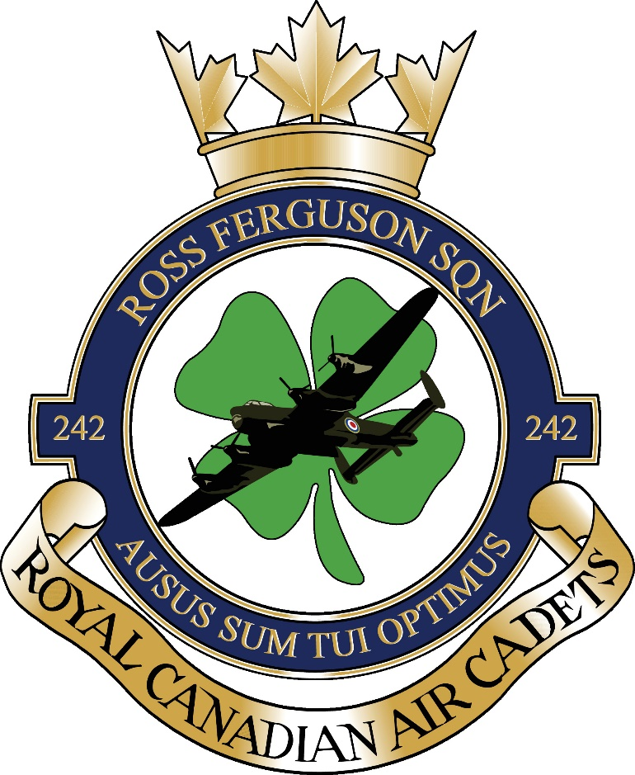

242 ROSS FERGUSON ROYAL CANADIAN AIR CADETS
INDIVIDUAL & CORPORATE
SPONSORSHIP PROGRAM

OUR ROOTS
The Ross Ferguson 242 Squadron operates out of the Erin Legion in Erin Ontario. The 242 Squadron is named in memory of a decorated local WWII veteran, Flt. Lt. Ross Ferguson.
He was born in Scotsguard, Saskatchewan in 1923 and made Erin Ontario his home. He enlisted in 1942 and was a navigator that completed two tours of duty in both Lancaster and Wellington Bombers. His career was distinguished by both a Distinguished Flying Cross, and then a bar to the DFC.
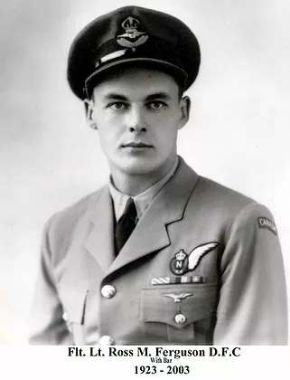

Squadron Created: September 02, 2003.

Supporting Sponsor: Branch 442 Royal Canadian Legion, Erin.

Original Commanding Officer: Capt. Keith Smith, CD.

Commanding Officers Since Inception: Capt. Andrew Adamczak, CD.,
Capt. Victoria Sullivan, Capt. Kathryn (Kate) Yap, CD., Capt. Eugene Sidlar., Capt. Doreen Marier.

Current Commanding Officer: Lt. (N) Amanda Street.

Current Sponsoring Committee (SSC) Chair: Venus Hood.

Your 242 Ross Ferguson Air Cadets Sponsorship will help fund our program to provide cadets with a full range of training opportunities, trips, and experiences in the air and on the ground.
Our Cadets greatly appreciate your donation as they gain lifelong memories and skills from the cadet program and make connections that are simply remarkable.

242 ROSS FERGUSON ROYAL CANADIAN AIR CADETS
SPONSORSHIP PROGRAM ENROLMENT FORM

INDIVIDUAL CORPORATE
$1,000 Platinum $5,000 Diamond
$500 Gold $3,000 Emerald
$250 Silver $1000 Platinum
$100 Bronze $500 Gold
________ Other amount $250 Silver
$100 Bronze
_______ Other amount
Individual/Corporation Name:

Address

Phone Number:

EMAIL:
Payment
Cash/EMT
Cheque made payable to: 242 Ross Ferguson Air Cadet Squadron

Please contact 242.chairperson@aircadetleague.on.ca with questions and start your sponsorship package today.

Donation receipts available upon request.

